Make a bright and colourful title at the top of your page and call it
CRIME AND PUNISHMENT
This is our topic for the term.
 | Make a list of bullet points of famous or local criminals that you know and a quick note of what they did. Include literary criminals or criminals that you know of from books or films.
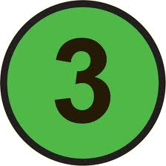 | Discuss with the people on your table if they know of any famous criminals. Ask them about the criminals that they know of and what they have done. Add these people to your list.
Write in your book a definition explaining
what is punishment?
 | Make a list of bullet points punishments that you know of. These might be in school, in real life, from the news, from history, from other cultures or from literature.
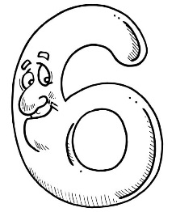 | Discuss with the people on your table if they know of any punishments. Ask them about their list and see if you can add some new ideas to your list.
Write a paragraph explaining the reasons why you think criminals or wrong-doers should be punished. Remember to use the SEED structure in your paragraph.
Statement (state your view)
Example (give an example of your view)
Explanation (give reasons why your view is logical)
Development (link to the wider world or society in general)
H O M E W O R K O P T I O N S
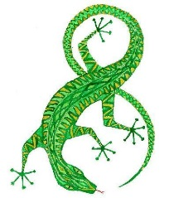 | Draw a picture about crime and punishment so that it can go on the classroom wall.  Ask Miss Lawler for some paper so you can do this.
Devise POSTER about crime and punishment so that it can go on the classroom wall.
Ask Miss Lawler for some paper so you can do this.
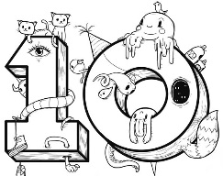 | Write a STORY that you have created about Crime and Punishment so that it can go on the classroom wall.

