iMac:Users:iMac:Desktop:Screen Shot 2016-12-19 at 4.16.07 pm.png

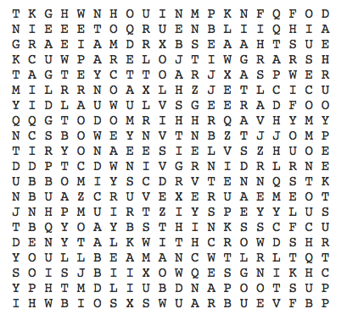

|  |  |
| --- | --- |
| iMac:Users:iMac:Desktop:Screen Shot 2016-12-19 at 4.16.16 pm.png | iMac:Users:iMac:Desktop:Screen Shot 2016-12-19 at 4.16.16 pm.png |