HOW TO WRITE A THEATRE REVIEW

What is a theatre review?

A theatre review is usually published in a newspaper. It helps people decide if a play is worthwhile going to see. It has 3 main parts:
- Acting
- Technical
- Overall view

Areas to include
When you write a review, it’s important to start with the name of the play, the date, venue and who performed it. You would also include some comments on the following:

Set design
Costume design
Lighting
Special effects
Sound
Movements
Vocal techniques
Director‘s interpretation
Acting techniques
Use of space
Use of levels

What you write about  - What did you see?  - What effect it had?  - If you liked it/or not? | 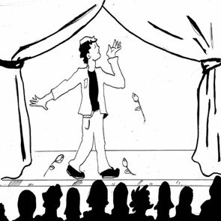
Writing style
The writing style is usually very honest and critical so it is okay to say what you feel/think. Do not worry about hurting anyone’s feelings. Critical evaluation is good so long as you can back it up with a reason.

Sentence Starters
You might use sentences that start with...
The effect that was created was......
The set looked......especially when combined with the lighting effect of ......
Costumes were (describing word example; stunning) and I liked them because......

Example Sentences
[DISLIKED] The shadows created by the lighting prevented the audience from reading the expressions on the actors’ faces
OR
[LIKED] The shadows created by the lighting helped the audience understand that suspicious events were about to happen.

Formulas:
You can choose your own method to write the review but if you are finding it difficult, there are formulas you can follow:
Suggested Sentence Formula: The audience (disliked/liked) the (set, lighting, acting, style) because it created (x, y, z) effect. This is relevant to the play because (a,b,c).
Suggested Review Formula: Paragraph 1 write about the visual impact of the play, lighting, costume
In paragraph 2, write about the director’s style, the combination of the effects and any special effects in relation to the plays themes. In paragraph 3, write about the actors, their movements, use of voice and interpretation of the character. In paragraph 4, write about the overall impact of the play and conclude with a recommendation from yourself about whether you would advise somebody to go and see the play.

